**Kelompok 7 Kecerdasan Bisnis**

Tofan Adi Nugroho 22-131

Muhammad Hablul Warid Ghazali 22-019

Andre 22-028

Nico Dwi Putra 22-101

Surya Eka Santoso 22-149

1. Menampilkan jumlah reservasi berdasarkan bulan.

Query :

SELECT

arrival_date_month AS Bulan,

COUNT(*) AS jumlah_Reservasi

FROM `kelompok-7-451502.hotel_booking.Hotel_Booking`

GROUP BY arrival_date_month

ORDER BY jumlah_Reservasi DESC;

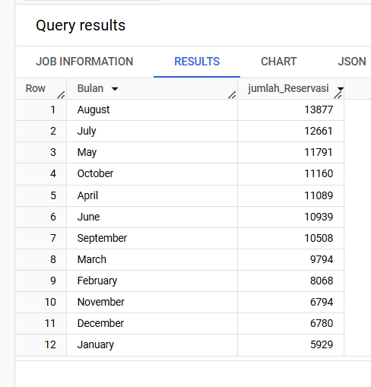

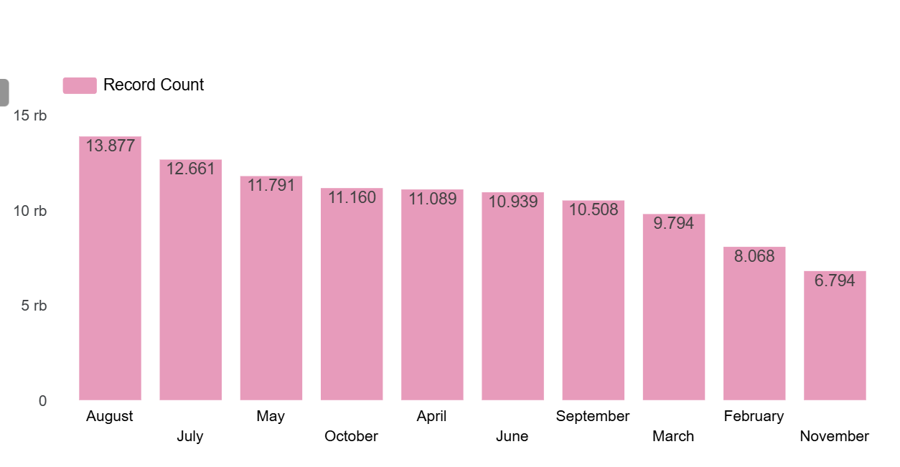

1. Menampilkan berapa malam paling banyak dipesan oleh tamu berdasarkan jumlah malam di weekday dan weekend.

Query:

SELECT

stays_in_week_nights AS Hari_Kerja,

stays_in_weekend_nights AS Hari_Weekend,

COUNT(*) AS Jumlah_reservasi

FROM `kelompok-7-451502.hotel_booking.Hotel_Booking`

GROUP BY Hari_Kerja, Hari_Weekend

ORDER BY Jumlah_reservasi DESC;

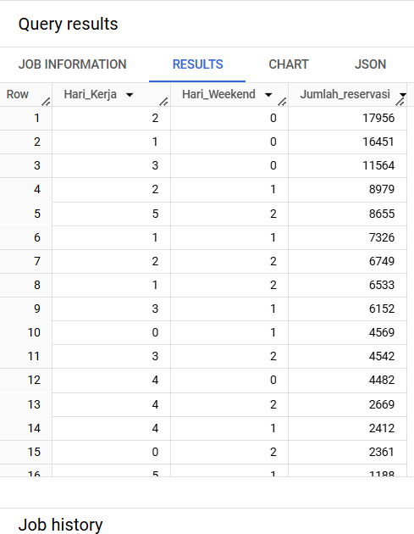

1. Menampilkan jumlah reservasi berdasarkan negara asal tamu hotel.

Query :

SELECT

country AS Negara,

COUNT(*) AS Jumlah_reservasi

FROM `kelompok-7-451502.hotel_booking.Hotel_Booking`

GROUP BY Negara ORDER BY Jumlah_reservasi DESC;

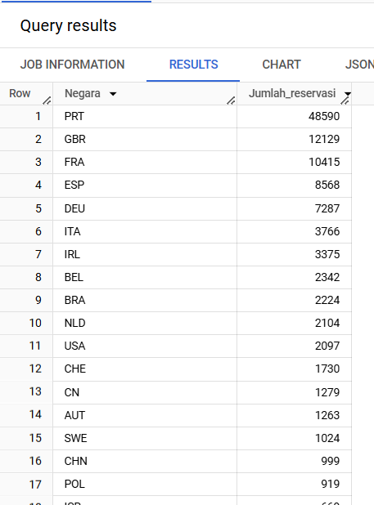

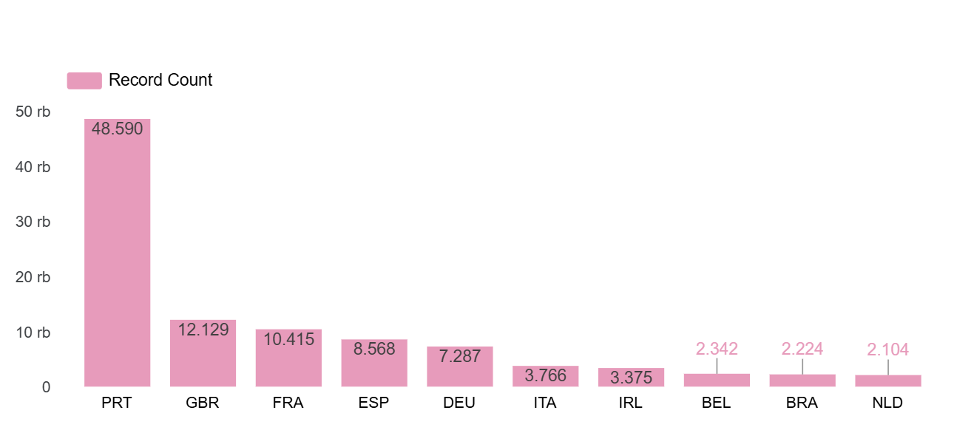

1. Menampilkan perbedaan rata-rata waktu hari pemesanan antara reservasi dibatalkan atau tidak.

Query :

SELECT

CASE

WHEN is_canceled = 0 THEN 'Tetap Check-in'

WHEN is_canceled = 1 THEN 'Dibatalkan'

END AS Status_Reservasi,

AVG(lead_time) AS Rata_rata_hari

FROM `kelompok-7-451502.hotel_booking.Hotel_Booking`

GROUP BY is_canceled;

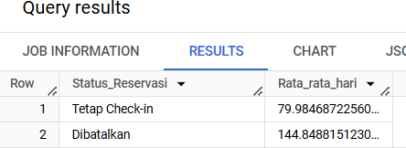

1. Menghitung jumlah total reservasi serta tingkat persentasi pembatalan (%) dari reservasi yang dibatalkan.

Query :

SELECT

COUNT(*) AS jumlah_reservasi,

SUM(is_canceled) AS jumlah_dibatalkan,

CONCAT(ROUND(SUM(is_canceled) * 100.0 / COUNT(*), 0), '%') AS persentasi_dibatalkan

FROM `kelompok-7-451502.hotel_booking.Hotel_Booking`;

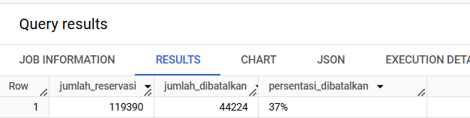

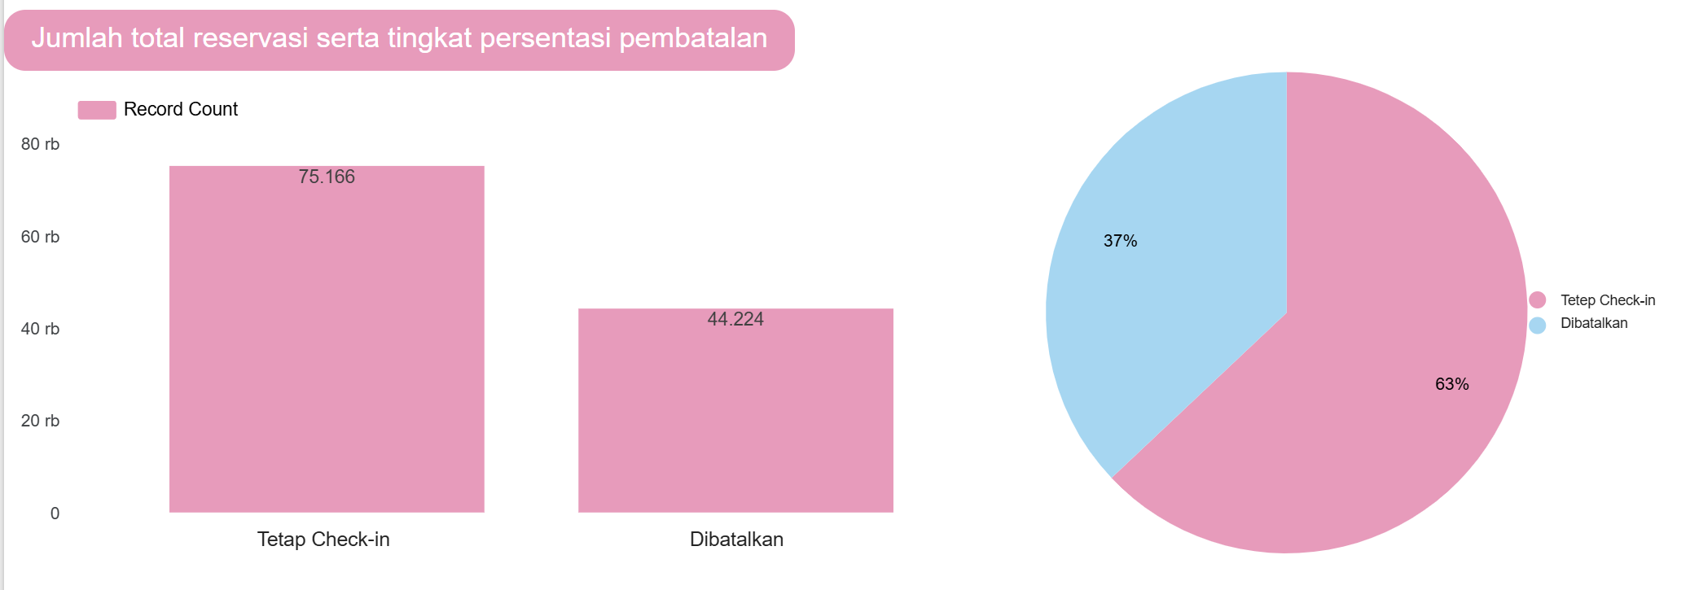

1. Menampilkan jumlah reservasi berdasarkan bulan dan tahun.

Query :

SELECT

    arrival_date_month AS Bulan,

    arrival_date_year AS Tahun,

    COUNT(*) AS jumlah_Reservasi

FROM `kelompok-7-451502.hotel_booking.hotel`

GROUP BY arrival_date_year, arrival_date_month

ORDER BY jumlah_Reservasi DESC;

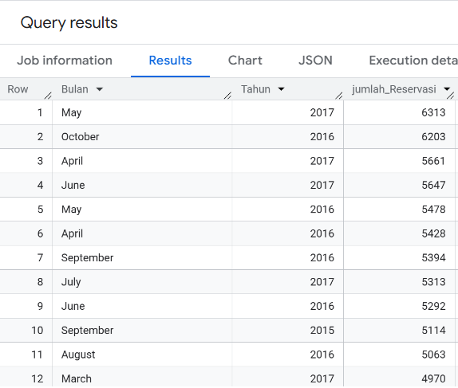

1. Menampilkan Tipe Kamar yang paling sering dipesan

SELECT

    reserved_room_type AS Tipe_Kamar,

    COUNT(*) AS jumlah_Reservasi

FROM `kelompok-7-451502.hotel_booking.hotel`

GROUP BY reserved_room_type

ORDER BY jumlah_Reservasi DESC;

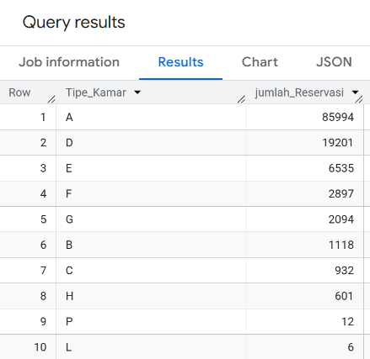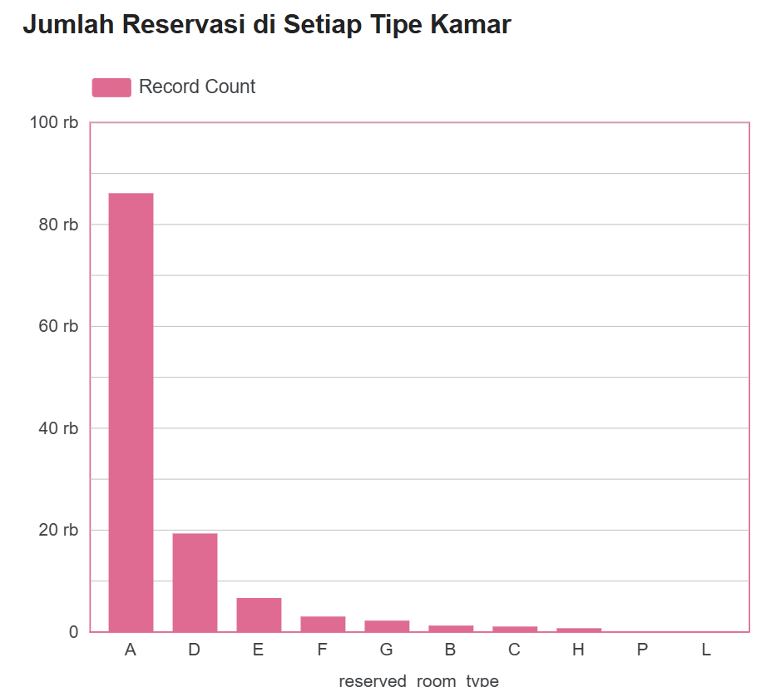

1. Menampilkan asal negara tamu hotel yang sering melakukan pembatalan

SELECT

country AS Negara,

COUNT(is_canceled) AS Jumlah_Pembatalan

FROM `kelompok-7-451502.hotel_booking.hotel`

GROUP BY country

ORDER BY Jumlah_Pembatalan DESC;

